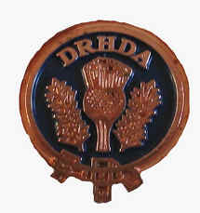

D.R.H.D.A Annual General Meeting

Saturday, October 29th 2011

Notre Dame Secondary School, Ajax

(Immediately following the competition)

All members are encouraged to attend and provide feedback on our quarterly Highland Dance competitions. This is your chance to pass on your opinion! In addition, nominations will be conducted to fill any outstanding Executive positions.

This year, we are looking for several new volunteers to join our executive committee. **We need people to help keep the DRHDA running.** If you have computer skills, organizational skills, and/or just want to be part of the DRHDA, please join us at our meeting.

Skills required:

* None! Other than an interest in supporting the highland dancers in our community
* Anyone specifically interested in maintaining our Association website, however, would be gratefully welcomed!

Executive Member Time commitment:

* Attendance at four competitions per year (if possible)
* A two-hour Executive meeting held prior to each competition at a central Durham Region location
*         Additional minimal time may be required occasionally to complete your volunteer task on your own time

Venue:

*        The DRHDA Executive has been struggling to locate an affordable venue in Durham Region for our competitions. Ideally, the location would have a stage and audience seating (not bleachers).  If any member has any suggestions or contacts, please contact a current Executive member.

See you on October 29th! Happy Dancing!!